***View-***

***Main table: student_data View table: stu_info***

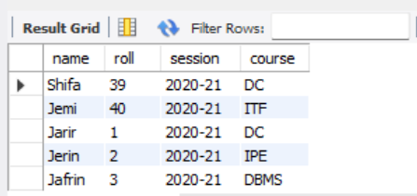 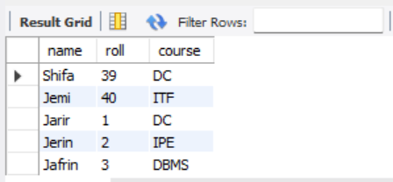

***View table:stu_info2 view table join operation:***

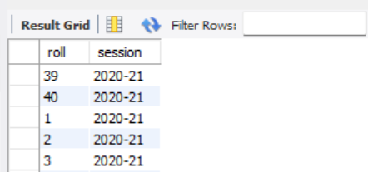 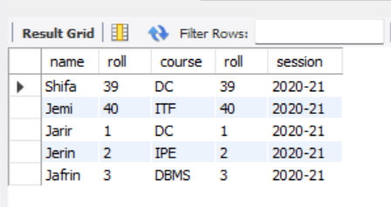

***view table update operation:***

***Before: ( View table: stu_info) update:***

 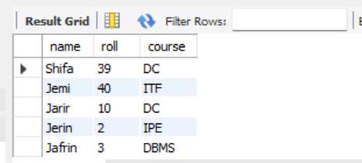

***view table delete operation:***

***Before: ( View table: stu_info) Delete:***  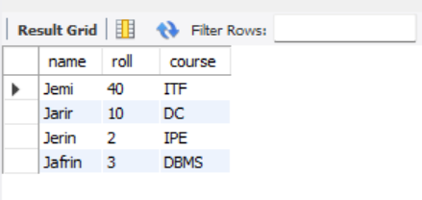

***Trigger: using timing (after)***

***Create trigger using insert (timing after):*** ***Trigger table show of table3***

***Table3: trigger_name:table5_insert:***

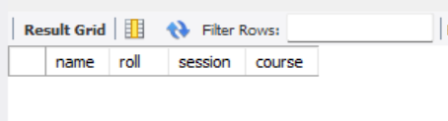 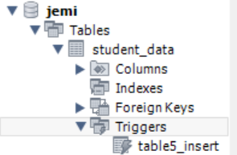

***Main table: student_data***



***After triggering insert operation main table: student_data***

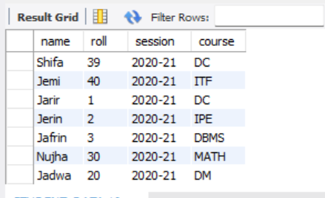

***After triggering insert operation trigger table:table3***

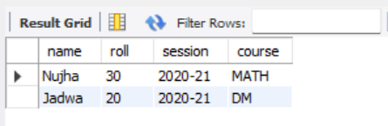

***Create trigger using update (timing after):*** ***trigger_name:table5_update:***

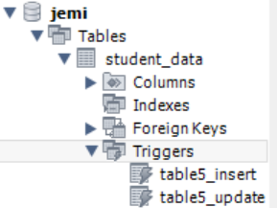

***After triggering update operation After triggering update operation main table: student_data trigger table:table3***

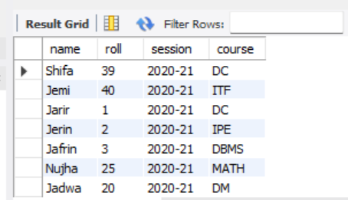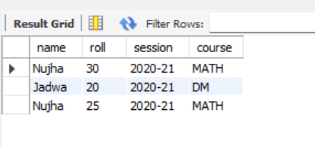

***Create trigger using update (timing after):*** ***trigger_name:table5_delete:***

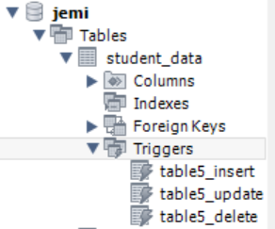

***After triggering delete operation After triggering delete operation trigger main table: student_data table: table3***

